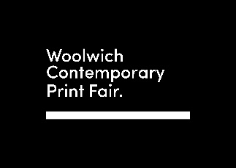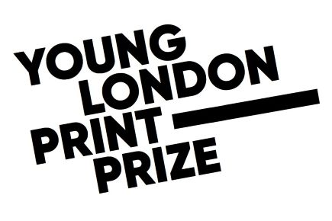

Poplar pupil, aged 10, wins London climate art prize
Press release (embargoed until 00.00 Thursday 03 November 2022)

A pupil aged just 10 from Poplar has beaten off competition from over 1,300 young artists to win this year’s Young London Print Prize.

As world leaders gather for the UN climate summit in Egypt, young people from across London have been invited to express their own artistic response to the climate crisis. The winning entry by Sara Ahmed, a Year 6 pupil from Mayflower Primary School in Tower Hamlets, depicts a single plastic bottle floating in the ocean. It was made using clay and ink with a technique called relief printing, and chosen by a group of seventeen year old students who judged all the submissions.

The second prize was scooped by Deimantas Pocuis from Discovery Primary School in Thamesmead for his striking print of a Hawksbill turtle and third prize by Prithvi Anish, a pupil at Foxfield Primary School in Woolwich, for her beautiful abstract monoprint entitled ‘The Sinking Ship’.

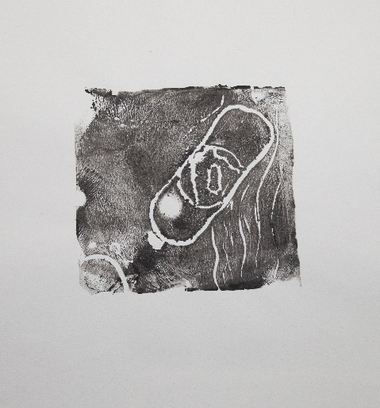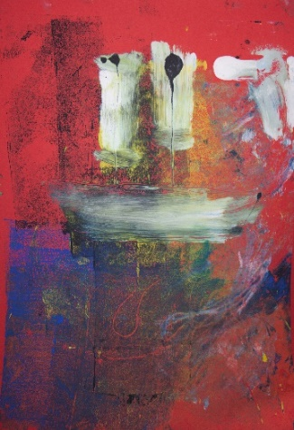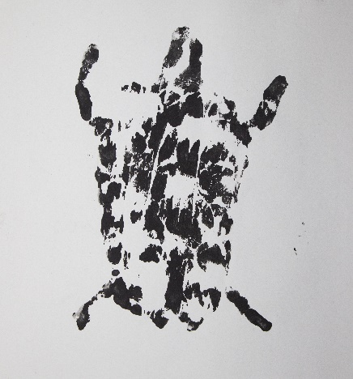

The Young London Print Prize is a competition launched during the Covid pandemic which aims to inspire and showcase the work of young artists. Uniquely, all the work is created and judged by young people themselves. 1,311 pupils from 23 schools took part this year.

Matt Bell, Chair of Woolwich Contemporary Print Fair and Co-Founder of the Young London Print Prize, said: “On the eve of COP27, this competition shows us how young people see the defining issue of their generation. Their art literally paints a picture of ecological meltdown. But it also contains expectation and hope. We can tackle the climate crisis – and we have to for their sake.”

According to the latest research, levels of concern about climate change are at an all-time high in Britain. Climate change is now seen as the second most important issue facing the country over the next 20 years, after Brexit (Cardiff University and Climate Outreach, 2022) and Londoners are more worried about climate change than people in any other part of the UK (YouGov, 2022).
Ben Jones, who teachers the winning pupil, Sara Ahmed, said: “Projects like this showcase the creativity and ambition in places like East London. They allow schools to collaborate with arts organisations in a meaningful way. And it’s a total joy to see how excited our pupils get when their work is viewed by the public in a space outside of school.”

You can see the work of these young artists on display at Woolwich Contemporary Print Fair from 3-6 November 2022. They are being exhibited alongside more than 500 artists from across the globe, including big names such as Grayson Perry, Yinka Shonibare, Gavin Turk and Julian Opie at Woolwich Works, London’s latest creative district. www.woolwichprintfair.com.

The Young London Print Prize is run by Woolwich Contemporary Print Fair in partnership with Landsec, Peabody, Anthesis, Boodle Hatfield and the Foundation for Future London. If you or your school are interested in taking part next year, please contact: matt@woolwichprintfair.com
----------------
All media enquiries and for high res images contact matt@woolwichprintfair.com

Woolwich Contemporary Print Fair showcases the best contemporary printmaking from across the globe. It nurtures emerging talent and inspires people of all ages to learn and collect. This is the largest print fair of its kind in Europe.

https://www.ukclimateresilience.org/blog/public-opinion-on-climate-change-is-up-but-lets-not-forget-lessons-from-the-past/
https://docs.cdn.yougov.com/hdemoi825d/Internal_ClimateChangeTracker_220720_GB_W.pdf

