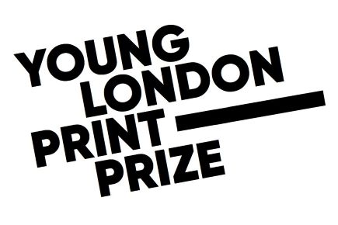
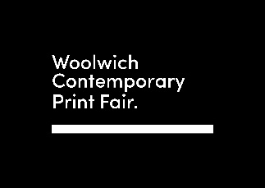

PRESS RELEASE
Young Londoners Use Art to Voice Climate Dreams on 50th Anniversary of World Environment Day
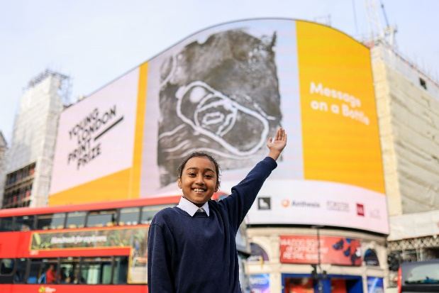

London, Tuesday 6 June, 2023: A competition inviting young Londoners to express their response to the climate crisis through art launches today on the 50th anniversary of World Environment Day.

Nearly 2,000 young artists between the ages of 9 and 11 from 37 schools across the capital are taking part, with the winners announced in October on the Piccadilly Lights.
The Young London Print Prize ran for the first time during the pandemic and has quadrupled in size since. All the work is created, judged and curated by young people themselves. The competition celebrates their creativity and the many ways that art and culture can inspire an ecological renaissance.

Turning the spotlight on plastic pollution
In 2022, the Prize was won by Sara Ahmed, a Year 6 pupil from Mayflower Primary School in Tower Hamlets for an artwork called ‘Message on a bottle’. This year’s World Environment Day is themed around preventing plastic pollution, and Sara’s work, made using clay and ink with a technique called relief printing, speaks powerfully to this issue. Every year eight million tonnes of plastic ends up in the oceans. The equivalent of one bin-lorry load every minute.

London schools need art now more than ever
Fifty young people are taking part this year from Hawksmoor Primary School in Thamesmead. Their Year 6 teacher, Tazeem Akhtar, said: “Art offers children a special way of understanding and responding to the world. It think it’s incredibly important to develop their self-esteem and expression through the use of colour, texture, form, pattern and different materials and processes. This prize celebrates their individuality and enriches all our lives.”

The Prize is also backed by South London-born musician and performer, Love Ssega, whose latest work, PANGEA, explores climate change and social justice and premieres on 8 June on the Southbank. He said: “Young people are already ahead of us. They’re using the magic of artistic imagination to paint the greener future we need to create. Good luck to all the entrants!”

This year’s winners will be announced on the full screen of the Piccadilly Lights at 12pm on Wednesday 25 October, before being displayed at Woolwich Contemporary Print Fair from 26-29 October, alongside some of the world’s finest artists.

Commenting on behalf of London’s City Hall, the Deputy Mayor for Culture and the Creative Industries, Justine Simons OBE said: “Art and culture have the power to shift perceptions, to allow us to see things in a new way, and help shine a light on the climate emergency. I am delighted that on the 50th Anniversary of World Environment Day so many young Londoners will be part of this year’s Print Prize competition, using their incredible creative talents to express their response to one of today’s biggest challenges - climate change.”

The Young London Print Prize is run by Woolwich Contemporary Print Fair, with fantastic support from Peabody, the Foundation for Future London, Landsec, the London Borough of Hammersmith & Fulham, Boodle Hatfield LLP, Anthesis, Lefranc Bourgeois, and Forster Communications. For more information, please visit https://woolwichprintfair.com/young-london-print-prize If your school is interested in taking part in the Prize, please contact: margo@woolwichprintfair.com.
ENDS
Woolwich Contemporary Print Fair is the largest art fair of its kind in Europe today. Our mission is to build a global platform championing contemporary print, together with creatives, collectors, visitors and the next generation of art lovers. www.woolwichprintfair.com
Love Ssega is an artist, songwriter and producer. He is currently Artist in Residence with the Philharmonia. His music blends a mix of New Wave, 80s Hip-Hop, African polyrhythms and NYC Disco into smart, modern Pop and has been played all over the world. He is the founding songwriter and lead vocalist of Grammy Award-winning Clean Bandit. https://www.instagram.com/lovessega/

